|  |
| --- |
| **LECTURE -04**      **Letter of Recommendation**    ***Course Instructor: Laiq Hasan*** |

▪

A

letter

written

by

a

previous

employer,

professor,

colleague,

client

or

a

teacher

for

recommending

an

individual's

work

or

academic

performance

.

▪

The

goal

of

recommendation

letter

is

to

vouch

for

the

skills,

achievements

and

aptitude

of

the

person

being

recommended

.

**What is a letter of Recommendation?**

C

S

E

-

31

1

:

Technical Writing



▪

A letter of recommendation is usually required when applying for

▪

Higher studies (MS,PHD etc.)

▪

Internships.

▪

Jobs etc.

▪

It

is

a

very

important

part

of

the

application

and

is

given

high

weightage

by

the

admission

committees/recruiters

.

**Where is it needed?**

C

S

E

-

31

1

:

Technical Writing



▪

Request

a

recommendation

letter

from

people

who

know

you

and

your

capabilities

,

such

as

▪

Former

employers

.

▪

Teachers

.

▪

Coaches

.

▪

I

nfluential

friends

who

have

known

you

for

a

long

time

.

▪

Relatives

are

not

a

good

choice

.

▪

Be

sure

to

give

the

referee

enough

time

to

write

the

reference

letter

.

**Requesting a Letter of Recommendation**

C

S

E

-

31

1

:

Technical Writing

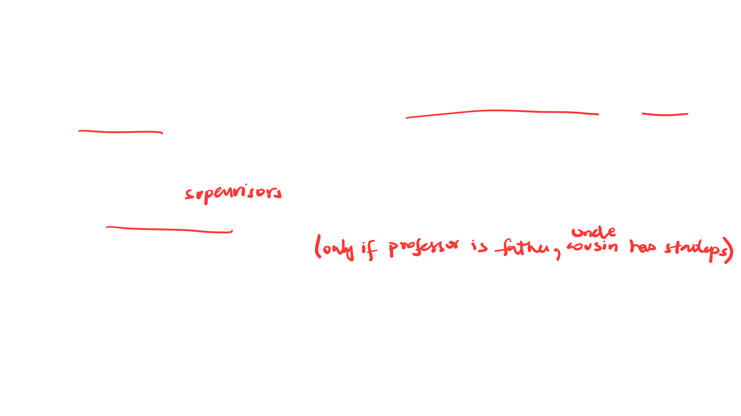

▪

Tell

the

people

who

agree

to

write

letters

for

you

about

your

goals

and

what

they

could

write

that

would

help

you

achieve

those

goals

.

▪

I

t

may

be

helpful

to

suggest

specific

phrases

or

sentences

that

the

writer

could

write

in

your

letter

.

▪

Once

you

receive

your

recommendation

letters

,

send

the

writers

thank

-

you

notes

.

▪

It

is

always

a

nice

gesture

to

let

each

writer

know

about

your

subsequent

success

and

how

much

their

letters

helped

you

to

attain

your

goal

.

**Continued..**

C

S

E

-

31

1

:

Technical Writing

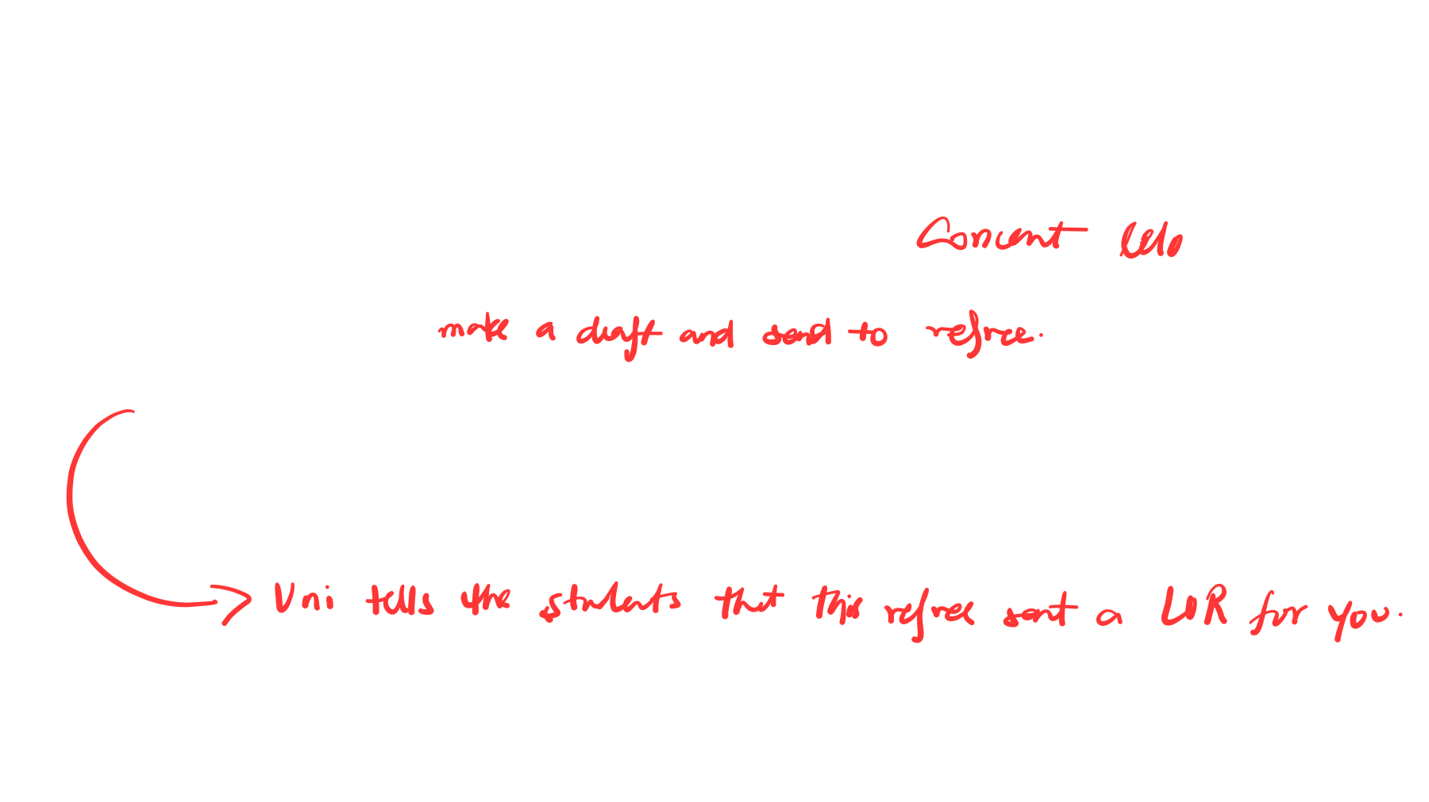

**Guidelines**

▪

Explain

how

you

know

the

applicant

and

how

long

you

have

known

him/her

.

▪

Explain

in

what

respect

is

this

person

exceptional

to

others

you

have

known

with

a

similar

background

.

▪

Describe

t

he

applicant's

exceptional

qualities

and

skills,

especially

those

which

are

related

to

the

applicant's

field

of

interest

or

job

search

.

▪

Present

specific

examples

to

back

up

what

you

have

written

.

**Writing a Letter of Recommendation**

C

S

E

-

31

1

:

Technical Writing

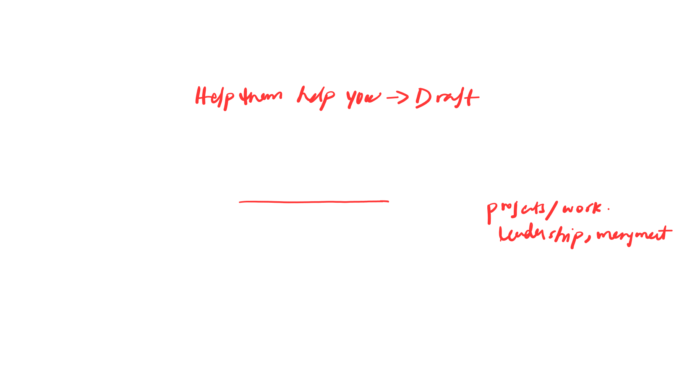

▪

Talk

about

the

candidate's

competencies

like

▪

Organizational

and

communication

skills

.

▪

Academic

and

other

achievements

.

▪

Interaction

with

others

.

▪

Sound

judgment

.

▪

Reliability

.

▪

Analytical

ability

.

▪

Emphasize

key

points

from

the

candidate’s

resume

that

you

want

the

reader

(

employer,

admission

committee

etc

.

)

to

take

note

of

.

**Continued..**

C

S

E

-

31

1

:

Technical Writing



▪

Generally,

a

letter

of

recommendation

for

employment

is

one

page

while

for

academic

programs,

it

maybe

longer

up

(

to

two

pages)

.

▪

Unless

it

is

absolutely

relevant,

do

not

refer

either

(

in

a

direct

or

implied

reference)

to

the

applicant's

race,

religion,

national

origin,

age

,

disability,

gender,

or

marital

status

.

**Continued..**

C

S

E

-

31

1

:

Technical Writing

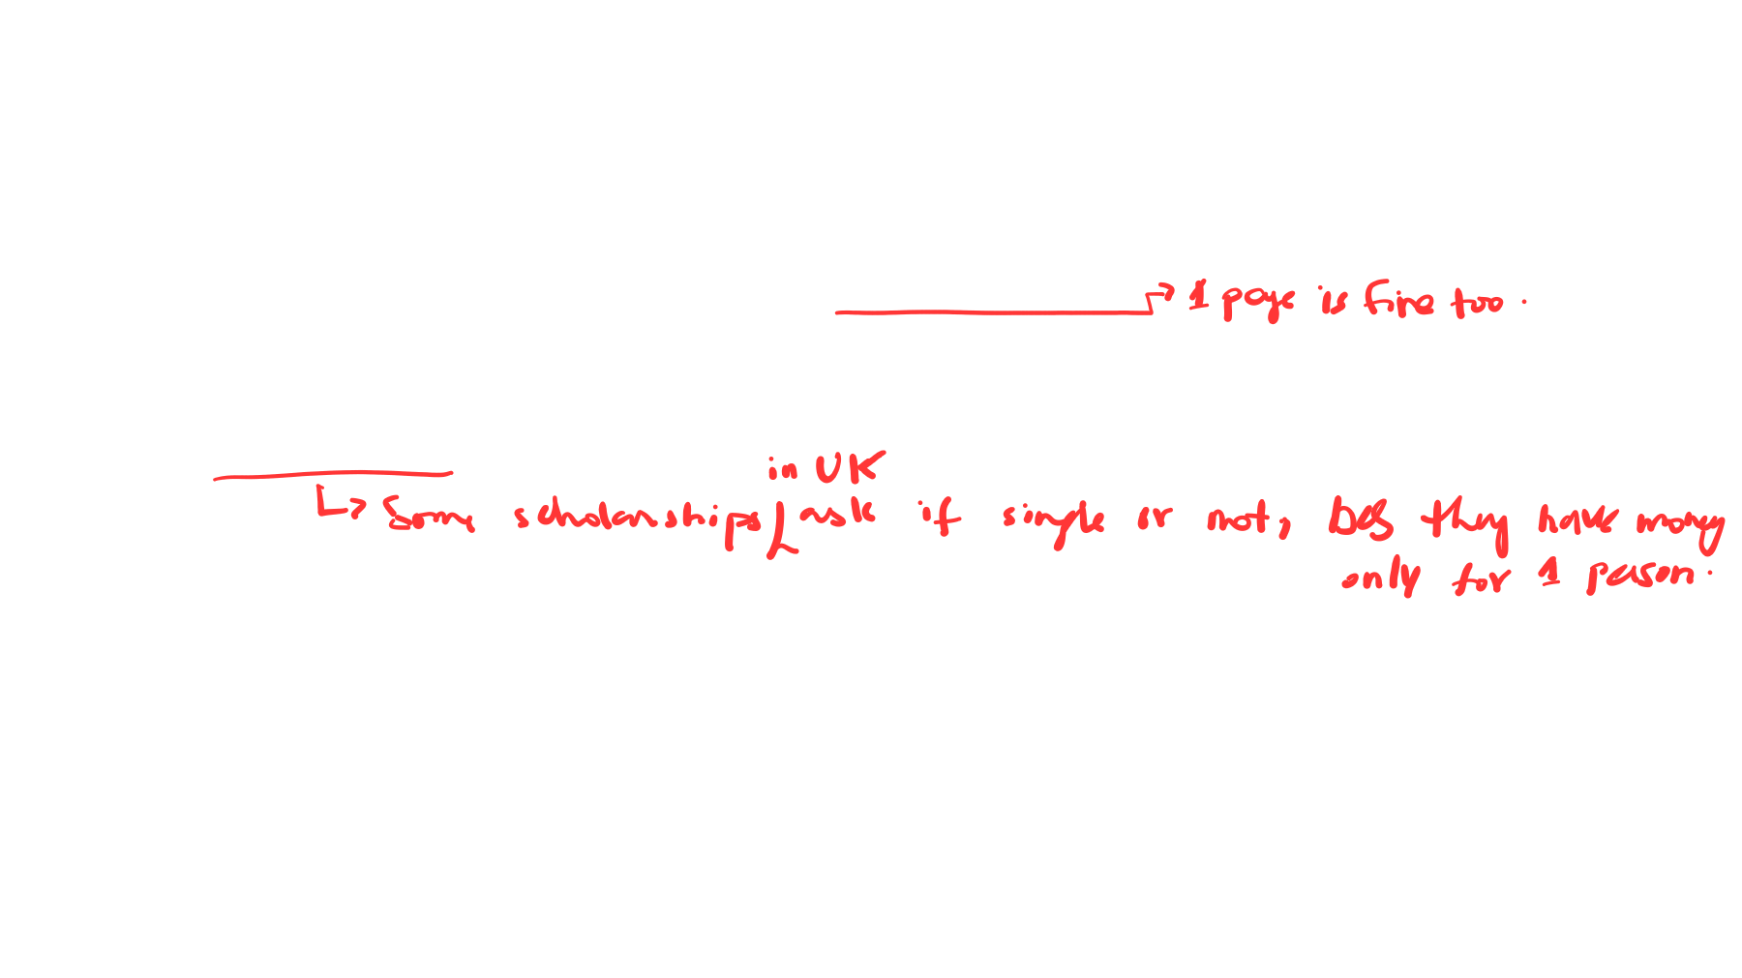

CSE-311: Technical Writing

# Recommendation Letter Template

Typically, a Recommendation Letter has the following structure ▪ Salutation.

* Paragraph 1. ▪ Paragraph 2. ▪ Paragraph 3.
* Summary.
* Conclusion.

▪

If

you

are

writing

a

personal

letter

of

recommendation,

include

a

salutation

(

Dear

Dr

.

Smith,

Dear

Mr

.

Jones,

etc

.

)

.

▪

If

you

are

writing

a

general

letter,

say

"To

Whom

it

May

Concern"

or

simply

do

not

include

a

salutation

.

**1**

**. Salutation**

C

S

E

-

31

1

:

Technical Writing

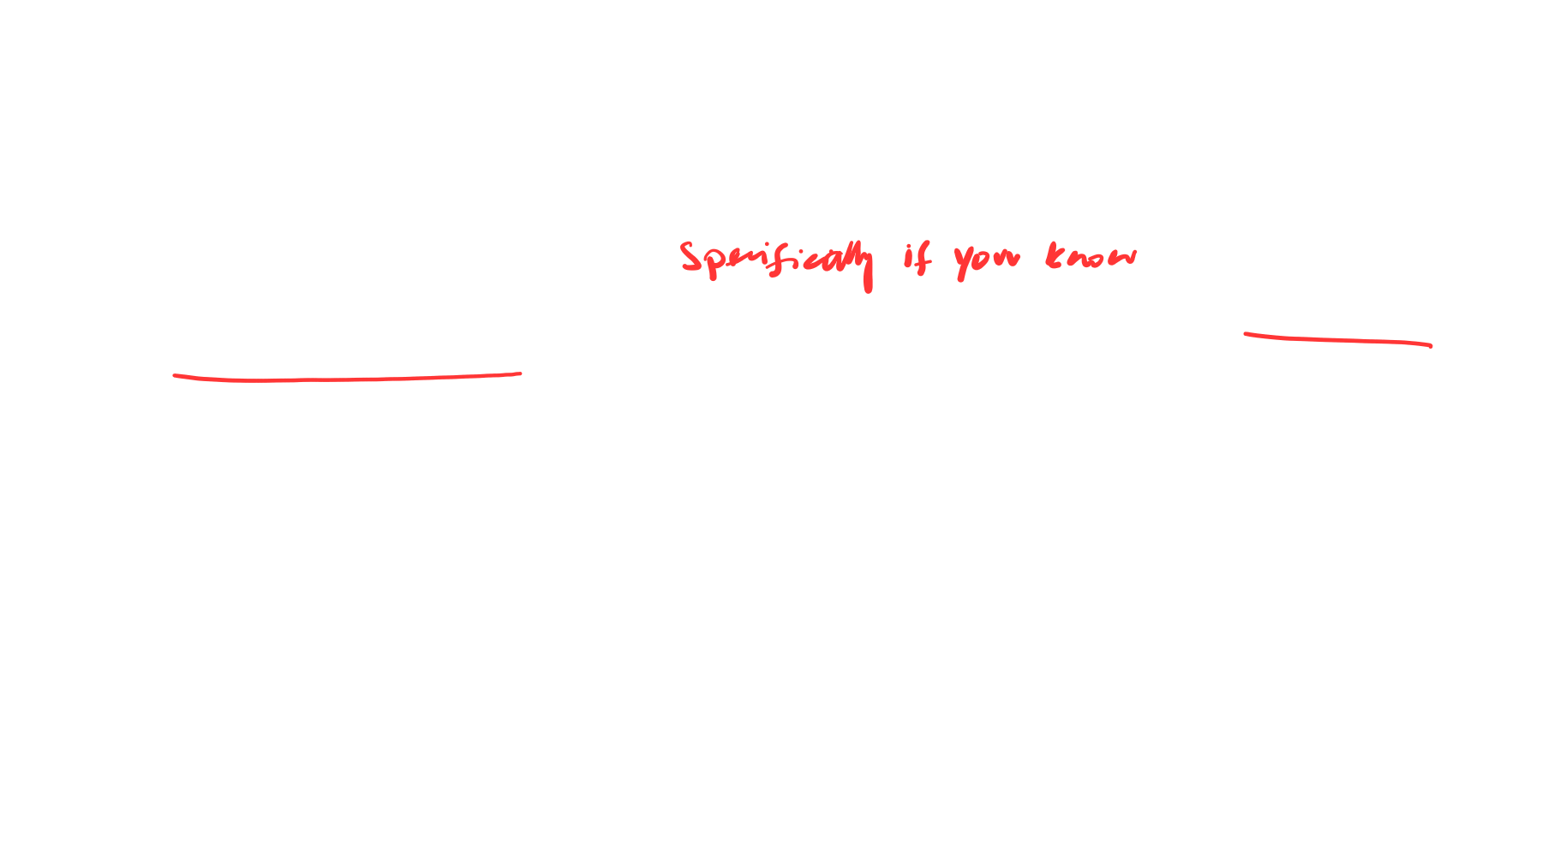

The

first

paragraph

of

the

recommendation

letter

explains

your

connection

to

the

person

you

are

recommending

i

.

e

.

▪

H

ow

you

know

him/her?

▪

W

hy

you

are

qualified

to

write

a

reference

letter

to

recommend

employment

or

admission

to

graduate

school?

**2**

**. Paragraph 1**

C

S

E

-

31

1

:

Technical Writing



▪

The

second

paragraph

of

the

recommendation

letter

should

contain

specific

information

on

the

person

you

are

writing

about

including

▪

Why

s)he

(

is

qualified?

▪

What

makes

him/her

stand

out?

▪

What

(

s)he

can

contribute

?

▪

If

necessary,

use

more

than

one

paragraph

to

provide

details

.

**. Paragraph**

**3**

**2**

C

S

E

-

31

1

:

Technical Writing



▪

This

paragraph

should

include

information

on

how

the

person's

skills

match

the

position

they

are

applying

for

.

▪

Ask

for

a

copy

of

the

job

posting

and

a

copy

of

the

person's

resume

so

you

can

target

your

reference

letter

accordingly

.

**3**

**4**

**. Paragraph**

C

S

E

-

31

1

:

Technical Writing



▪

This

section

of

the

recommendation

letter

contains

a

brief

summary

of

why

are

you

recommending

the

person

.

▪

State

that

you

"highly

recommend"

the

person

or

you

"recommend

without

reservation"

or

something

similar

.

**. Summary**

**5**

C

S

E

-

31

1

:

Technical Writing



▪

The

concluding

paragraph

of

the

reference

letter

contains

an

offer

to

provide

more

information

.

▪

Contact

details

can

be

given

in

the

return

address

section

of

your

letter,

or

in

your

signature

.

**6**

**. Conclusion**

C

S

E

-

31

1

:

Technical Writing



**Recommendation Letter Sample**

C

S

E

-

31

1

:

Technical Writing

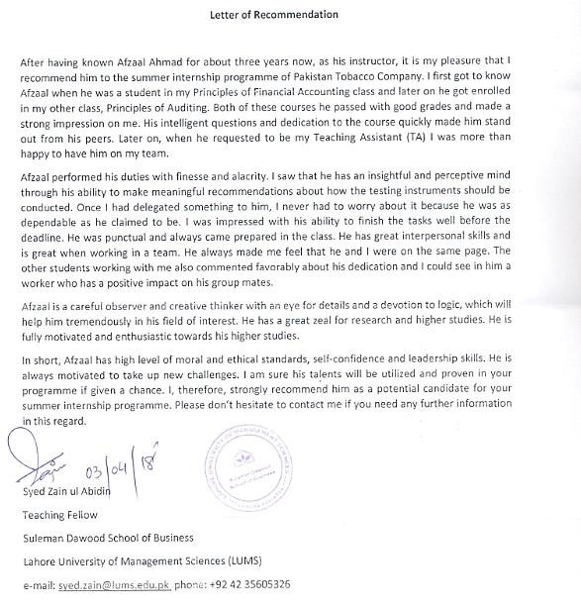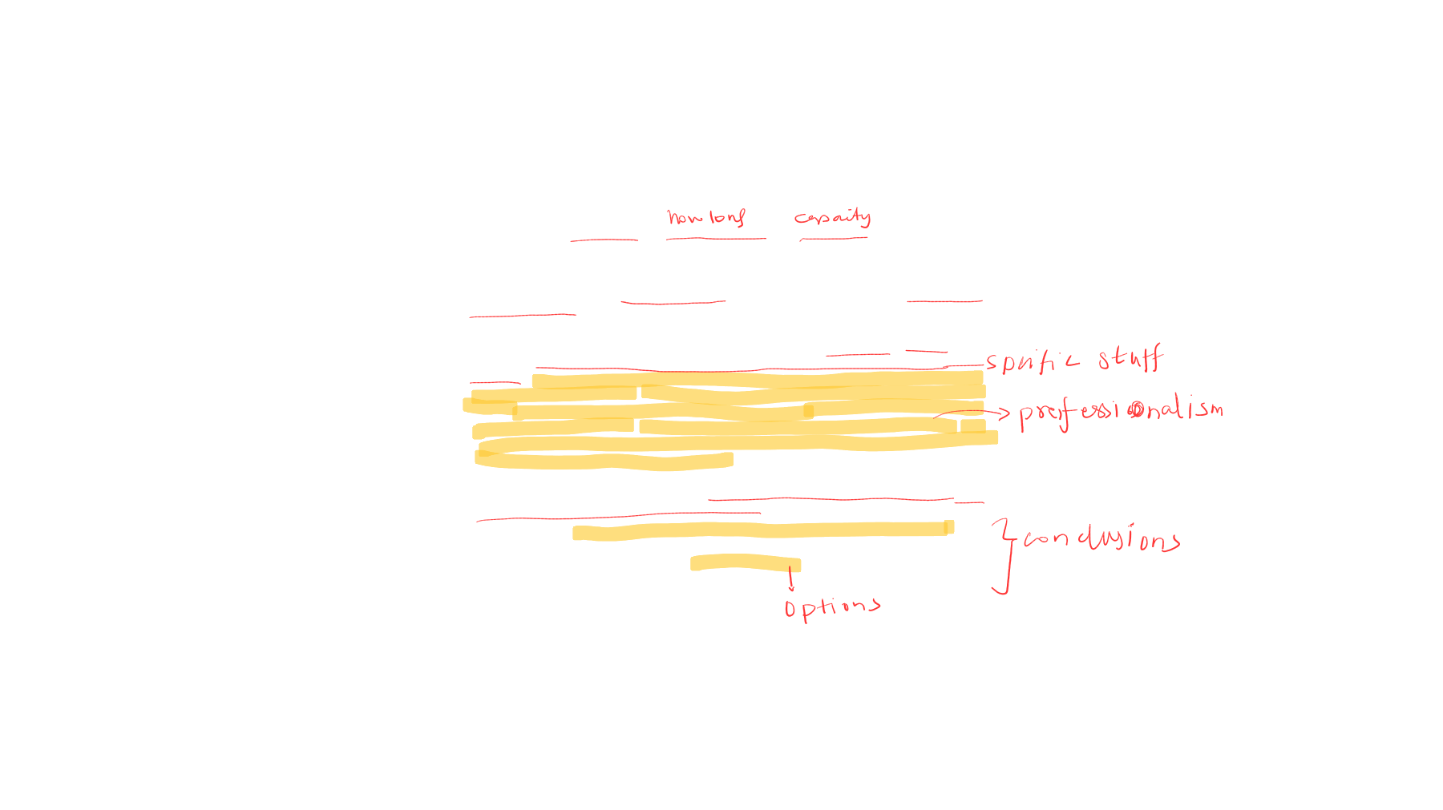

CSE-311: Technical Writing

# Assignment

* Suppose you are applying for graduate school or for a job in a company of your choice.
* Write a recommendation letter on your referee’s behalf for yourself keeping in mind the guidelines.
* Submit your assignment before the class next week.

CSE-311: Technical Writing

# Acknowledgement

The content presented in this lecture is inspired by miscellaneous sources.

* [Writing-letters-of-recommendation-PACE UNIVERSITY CAREER SERVICES](https://www.pace.edu/career-services/sites/default/files/files/pdf/writing-letters-of-recommendation.pdf).
* [Writing good letter of recommendations](https://mitadmissions.org/apply/parents-educators/writingrecs/).